Sung Chi

CS151

Assignment 1 part 1

Airplane Reservation System

**Use Cases**

Use Case: Make a reservation for 1 passenger

|  |  |  |
| --- | --- | --- |
| Steps | User’s Action | System’s Response |
| 1 | User presses [P] for adding passenger |  |
| 2 |  | The ARS prompts user to enter name;  Name: |
| 3 | User enters his/her name |  |
| 4 |  | The ARS prompts user to enter service class;  Service Class: |
| 5 | User enters desired class |  |
| 6 |  | The ARS prompts user to enter seat preference;  Seat Preference: |
| 7 | User enters seat preference |  |
| 8 |  | The ARS finds the first preference matching seat and reserves the seat. |

Use Case: Make a reservation for group of passenger

|  |  |  |
| --- | --- | --- |
| Steps | User’s Action | System’s Response |
| 1 | User presses [G] for adding group of passengers |  |
| 2 |  | The ARS prompts user to enter group name;  Group Name: |
| 3 | User enters group name |  |
| 4 |  | The ARS prompts user to enter names of passengers;  Names: |
| 5 | User enters names of the passengers |  |
| 6 |  | The ARS prompts user to enter service class;  Service Class: |
| 7 | User enters desired service class |  |
| 8 |  | The ARS finds finds the row with the largest number of adjacent seats in any seat row and reserves the seats. |

Use Case: Cancel a reservation

|  |  |  |
| --- | --- | --- |
| Steps | User’s Action | System’s Response |
| 1 | User presses [C] for canceling reservation |  |
| 2 |  | The ARS prompts user to see if its Individual or group;  [I]ndividual or [G]roup?: |
| 3 | User enters the passenger type |  |
| 4 |  | The ARS prompts user to enter name(s) of passenger(s);  Names: |
| 5 | User enters name(s) of the passengers |  |
| 6 |  | The ARS finds the passenger(s) in the seating chart and cancels the reservation. |

Use Case: Print Availability Chart

|  |  |  |
| --- | --- | --- |
| Steps | User’s Action | System’s Response |
| 1 | User presses [A] for printing Availability chart |  |
| 2 |  | The ARS prints the available seats in the airplane. |

Use Case: Print Manifest Chart

|  |  |  |
| --- | --- | --- |
| Steps | User’s Action | System’s Response |
| 1 | User presses [M] for printing Manifest chart |  |
| 2 |  | The ARS prints the passenger names of the reserved seats. |

**CRC Cards**

|  |  |
| --- | --- |
| Connection | |
| Display Menu  Take User Input and Initiate service  Display Result | SeatManager  ReservationSystem  Passenger |

|  |  |
| --- | --- |
| ReservationSystem | |
| Prompt users to enter input | Connection |

|  |  |
| --- | --- |
| Passenger | |
| Contain Passenger information  :name, class preference, seat preference, group name, names | Connection |

|  |  |
| --- | --- |
| Flight | |
| Contain fixed seats  : first class , economy class  Manage Availability Chart  Search seats | Seat  SeatManeger |

|  |  |
| --- | --- |
| Seat | |
| Contain passenger info  Contains seat info  :seat number, position, availability | Passenger  Flight |

|  |  |
| --- | --- |
| SeatManager | |
| read existing file  create new file  make reservation  cancel reservation  update file  manage Manifest Chart | Connection  Seat  Flight |

**UML Class Diagram**

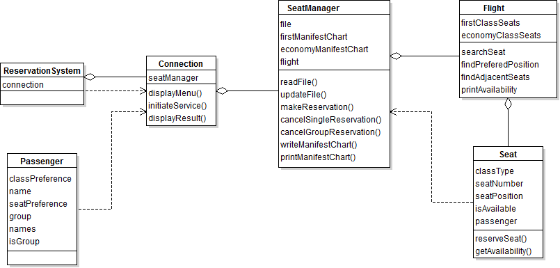

**UML Sequence Diagram**

1. Make a reservation for 1 passenger

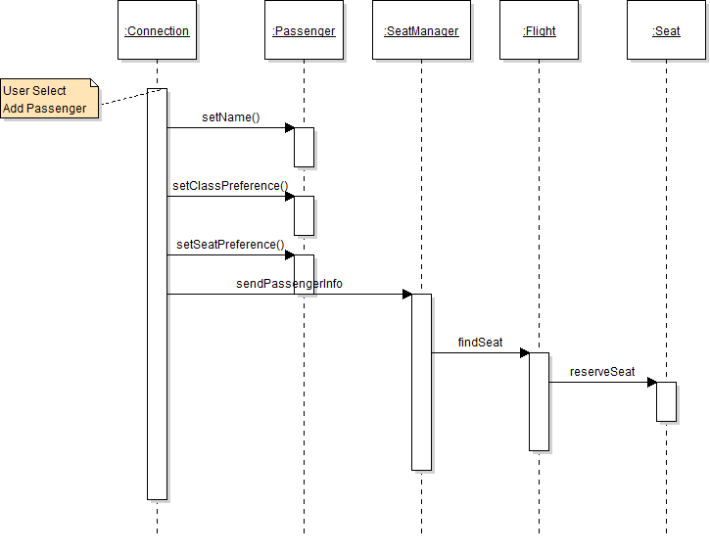

1. Make a reservation for group of passenger

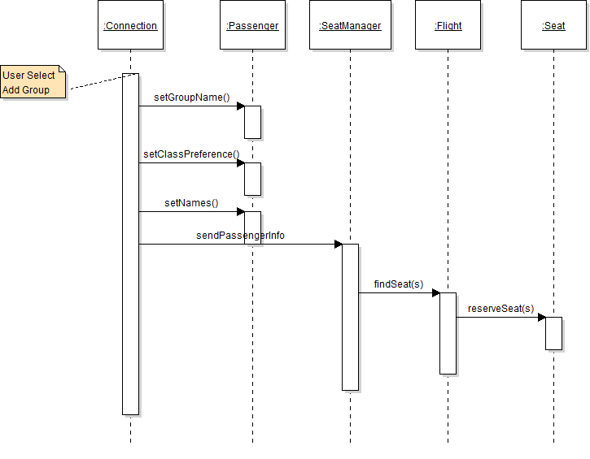

1. Cancel a reservation

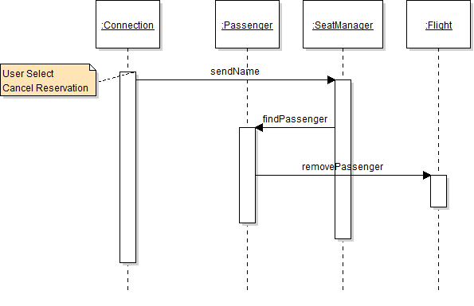

1. Print Availability Chart

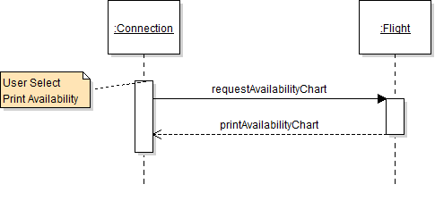

1. Print Manifest Chart

